<https://thought-leadership-production.s3.amazonaws.com/2016/10/28/17/17/50/0615788b-8eaf-4b4f-a02a-8819c68278ef/20160825_PHA_Report_FINAL.pdf>

It is quite arguable that land use controls have a more widespread impact on orginary Americans than any other regulatory regime, naturally, these have widespread affects on everything from the economy, to the environment, to local culture.

Urban trees:

* Soak up particle pollution, [a big problem](http://www.iea.org/publications/freepublications/publication/WorldEnergyOutlookSpecialReport2016EnergyandAirPollution.pdf) to health, [generally improving air quality](http://www.fs.fed.us/nrs/pubs/jrnl/2013/nrs_2013_nowak_002.pdf)
* Decrease temp of surrounding areas by multiple degrees, [enough to save lives on the margin](http://apps.who.int/iris/bitstream/10665/42792/1/9241580348_eng_Volume1.pdf), in addition to providing a cooler place to live
  + Almost certainly would bring down energy costs in regions that use air conditioning, saving money and mitigating climate change
* Retain storm water, boost property value, and possibly [provide mental-health benefits](https://www.ncbi.nlm.nih.gov/pubmed/22320203)

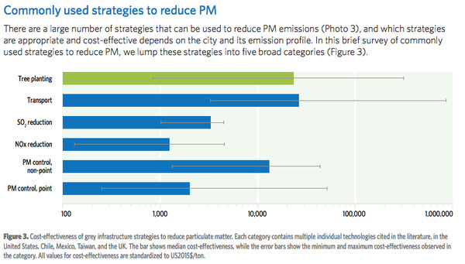

BUT:

* Has to in right place, with right trees
  + Only improve air quality in immediately area, ~30 meters
    - Prioritize dense areas
  + Pollution-trapping trees, ie ones with large trees
  + Trees can consume significant water, and if its limited, a city needs drought-tolerant species
  + [Prioritize less allergenic species](https://www.ncbi.nlm.nih.gov/pubmed/26310854)

Despite this:

* [Declining tree density](https://www.itreetools.org/Canopy/resources/Tree_and_Impervious_Cover_change_in_US_Cities_Nowak_Greenfield.pdf) in US, and globally. Wealthier European nations are the biggest exception.
  + [Largely due to emerald ash borer](https://www.washingtonpost.com/news/energy-environment/wp/2016/05/10/the-slow-motion-crisis-thats-facing-u-s-forests/)
    - Damage can be mitigated by diversifying trees

Urban sprawl:

REGULATORY ENVIRONMENT

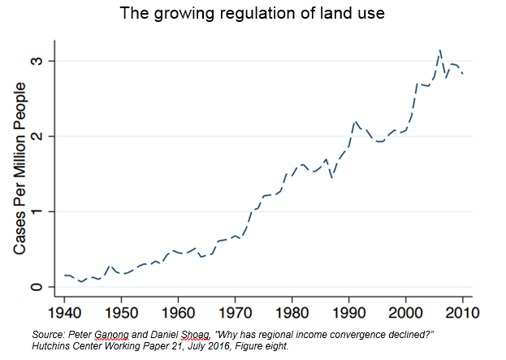

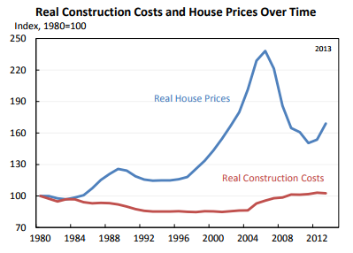

# Parking

* Despite sharing [little characteristics with public goods](http://www.econlib.org/library/Enc/PublicGoods.html), its commonly perceived by people and policy makers alike as one
  + Parking is free [for 99% of car trips](http://shoup.bol.ucla.edu/Trouble.pdf)
  + As there is (usually!) no such thing as a free lunch, we know that consumers pay for parking spots through their taxes, through the waste of valuable land (, [and by indirect subsidy of car driving](http://www.citylab.com/commute/2012/02/parking-minimums-promote-driving-even-transit-friendly-new-york/1331/).
    - [Study](http://today.uconn.edu/blog/2014/03/urban-parking-at-any-price/) found that Hartford, Connecticut loses $1,200 in tax revenue per spot, per year
    - Estimated [$127 billion subsidy to park](http://pwm.sagepub.com/content/early/2014/03/25/1087724X13514380.full.pdf+html)
    - Where parking is more expensive[, people will be more likely to take public transit](http://pwm.sagepub.com/content/early/2014/03/25/1087724X13514380.full.pdf+html)
  + This then causes a negative feedback loop with building code regulations
    - In many cities, such as Los Angeles, all new building must have a certain ratio of parking to residents, consumers, and/or employers.
      * Encourages large, luxury housing, instead of smaller, affordable housing
    - Again, raising operational prices for all businesses, who then raise rent / consumer prices to compensate
  + Regressive government spending, [as it disproportionately benefits higher income people](http://www.abag.ca.gov/services/finance/fan/housingmyths2.htm)
* Solutions:
  + Utilize market forces to approximate equilibrium prices of spot, using wifi-connected parking meters that adjust price based on supply and demand of spots in that area at the given time
    - [Cut parking cruising in half](http://people.ucsc.edu/~adammb/publications/Millard-Ball_Weinberger_Hampshire_2014_Assessing_the_impacts_SFPark.pdf)
    - [Driving in areas fell by 30 percent](http://www.sfmta.com/sites/default/files/pressreleases/SFpark%20Evaluation%20Presentation%206.19.14.pdf)
  + Eliminate regulations and let choice govern amount of spots

# Zoning

## Single-use Development

* Also known as Euclidean zoning, single-use zoning is a type of regulatory environment in which land use of a city or region is divided into residential, commercial, or industrial districts, or “zones’.
  + [Encourages suburban sprawl](http://readingroom.law.gsu.edu/cgi/viewcontent.cgi?article=1865&context=gsulr)
    - Obesity
    - Pollution
    - Decrease leisure time

## Housing constraints

* Forms of housing constraints:
  + Height limits
  + Rent control and stabilization
  + Minimum-house-size rules
    - Sometimes called “snob zoning”, explicitly started to price out poor people
  + Extensive permit process
* If New York, San Francisco, and San Jose alone eased their housing constraints to a level on par with the median city, [**the US economy would grow nearly 10%.**](http://chicagounbound.uchicago.edu/cgi/viewcontent.cgi?article=1045&context=housing_law_and_policy)
* Housing constraints in metropolitan areas from 1964 to 2009 [lowered US growth by more than 50%](http://www.nber.org/papers/w21154)

<https://cdn.citylab.com/media/img/citylab/legacy/2011/12/13/buf4.jpg>